Length of Stay: Shelter and Foster

Contents
Overview 2
Purpose and Scope 2
Purpose 2
Rationale 2
Scope 2
Operational Areas Encompassed 2
Methodology 3
Decisions 3
Stratification 3
Timeframe 3
Animals included 3
Calculations 4
Report Outputs 4
Technical Implementation 6
Source Data Updates 7
Current Code Repository 7
Report Generation Logic 7
Data Outputs 7
Excel-based Reporting File 7
Automation and Operations 7
Scheduled Execution 7
Report Change Log 8

Overview

Purpose and Scope

Purpose
This report includes (1) total length of stay (LOS) and (2) LOS while physically in the shelter.

Rationale
Many shelter animals are housed both in the shelter and in foster homes. Measuring total LOS misses some key nuances for shelters that rely on foster homes to maximize animal wellbeing until they find a permanent home, or if adoption is unrealistic.

While total LOS is a critical measure of shelter flow, efficacy and lifesaving capacity, LOS in-shelter more narrowly examines a key indicator of individual animal welfare.

Scope
The report summarizes toal LOS and LOS physically in the shelter. LOS in foster care can easily be calculated from the report but is not currently included.

Operational Areas Encompassed
LOS in-shelter (or total LOS) is not a medical metric per se, but the medical team can impact length of stay in a number of ways:
- Clear medical conditions as soon as possible so that animals can be made available for adoption
- Help educate adoption staff to communicate well with adopters about medical concerns
- Help support foster families
- Manage population flow through daily rounds with other teams
- Maintain high standard of infection control to minimize shelter-acquired illness
- Advocate for the organization remaining within its capacity for care

Methodology

Decisions

Population Scope | Dogs and cats chosen because they are the majority of animals in the shelter.
Stratification | - Stratified by location (shelter and foster home) because they reflect different levels of welfare.  - Stratified by with and without an outcome because these provide different information.
Inclusion/Exclusion | - Included all true shelter admissions to accurately reflect LOS to outcome. Other populations such as urgent foster program (animals not surrendered to the shelter) or TNR different categories and don’t belong with the surrendered population.
Main Measures | - Used median as the primary measure because LOS distributions are always skewed.

Stratification
- LOS as days-in-shelter and total days in care
- LOS for animals with an outcome (no longer in shelter care)
- LOS for animals without an outcome (i.e. still in shelter care)

Timeframe
LOS is reported monthly. It includes all of the time since admission for animals in the shelter’s care in the month in question. The report retains historical data for trend interpretation.

Animals included
Dogs and cats in the shelter’s care during the month in question i.e. dogs and cats already in care on the first of the month + new admissions during the month.

Calculations

Location records are analyzed to identify all periods in the shelter and all periods in foster care, and the program calculates LOS total and in-shelter based on these.

Animals with an outcome
Total LOS = outcome date – intake date
LOS in-shelter = total LOS – LOS in foster

Animals without an outcome
Total LOS = date at end of reporting period – intake date
LOS in-shelter = total LOS – LOS in foster

LOS variables reported
- Mean = the average of all values. All values are added together and divided by the number of values
- Median = the middle value or an ordered dataset. Values are sorted from smallest to largest. For odd number of data points, the median is the middle value (i.e. there is an equal number of values on either side). For an even number of data points, the median is the average of the two middle values
- Minimum = the shortest length of stay for the reporting period
- Maximum = the longest length of stay for the reporting period (calculated from the time of intake, not the start of the reporting period)

Report Outputs

This section provides selected screenshots of reports as they currently appear, to illustrate the output.

Length of stay in-shelter, for animals with an outcome

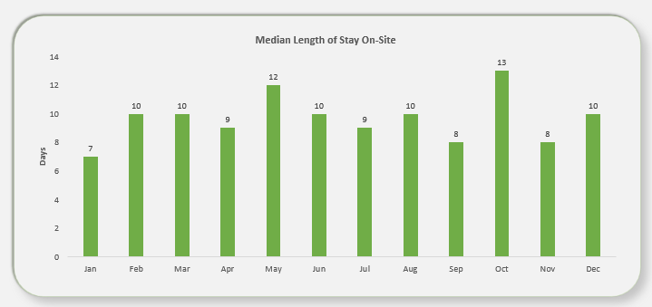

Length of stay in-shelter, for animals without an outcome

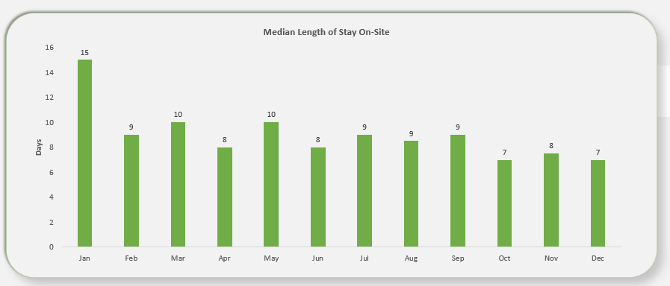

By double-clicking in the table beneath the graph for July (as an example), a tab is created with the details of the animals represented in that graph (unique IDs and numbers are included but cropped out in this example). This table shows LOS for some of the animals with outcomes in July.

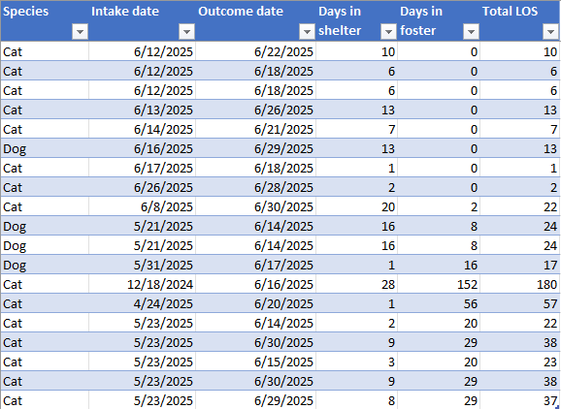

Technical Implementation

The execution script combines Python user-defined functions and SQL queries to extract the report files from a SQL server. By leveraging the capabilities of both Python and SQL, the script facilitates the retrieval and processing of the required data for generating the report files.

Source Data Updates
Source data are received from PetPoint on a recurring monthly basis via an automated file transfer process. The reporting process is designed to run after the monthly data file is received. Python code is used to refine source data and generate an output.

Current Code Repository
The current technical implementation for this report is available in GitHub:
THS-Metrics/metric-reports.

Report Generation Logic

Data Outputs

Excel-based Reporting File
The report’s Excel-based reporting file has been predesigned with tables and visualizations, with the data source being the output Excel file generated by the python script. generated by the Python script. Whenever the script is executed, the reporting file refreshes automatically, ensuring that it remains updated with changes in the underlying data.

Automation and Operations

Scheduled Execution
The reporting process is designed to be run automatically on a scheduled basis. Automation consists of executing the Python reporting script at a defined interval in an environment where required dependencies and credentials are available.

For this report, automation is intended to run once per month. Each execution refreshes the processed output files, which in turn update any downstream reporting or summary views that depend on them. Successful execution can be verified by confirming that output files have been updated for the current reporting period.

Automation may be implemented using any scheduling system capable of running a Python script (e.g. task schedulers, cron jobs, or workflow tools), provided the script is executed in a configured Python environment.

Report Change Log
MMDDYY | Change | Initials

